MODULE 2
1) Use the appropriate command to list all files larger than 1 MB in the current directory and save the output to a file.
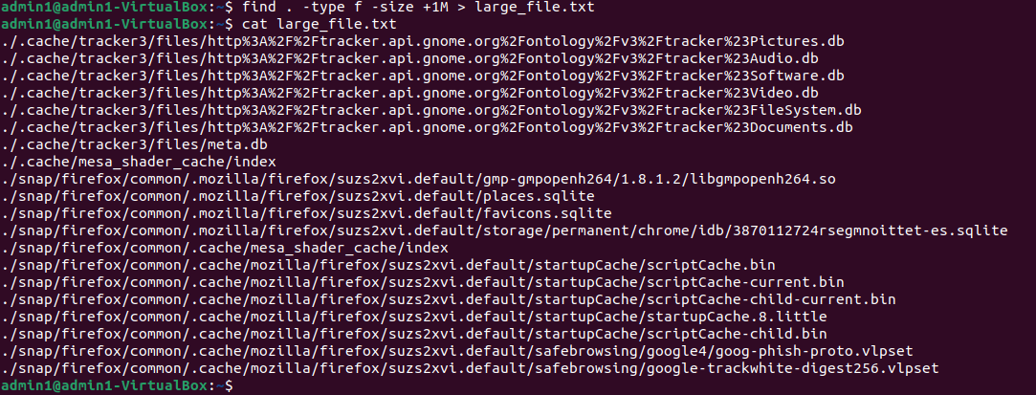

2) Replace all occurrences of "localhost" with "127.0.0.1" in a configuration file named config.txt, and save the updated file as updated_config.txt.
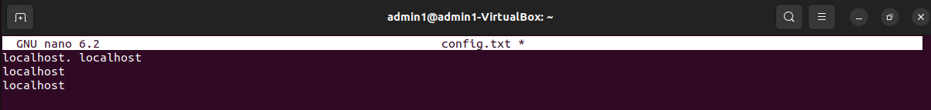
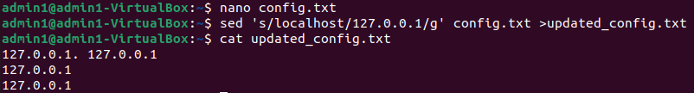

3) Use the appropriate command to search for lines containing the word "ERROR" in a log file but exclude lines containing "DEBUG". Save the results to a file named filtered_log.txt.
log:
DEBUG: Starting the application initialization.
ERROR: Unable to connect to the database.
INFO: User 'admin' logged in successfully.
DEBUG: Fetching configuration settings from the server.
ERROR: DEBUG - Configuration settings could not be applied.
INFO: Scheduled job 'backup' completed successfully.
DEBUG: Connection to server timed out. Retrying...
ERROR: Failed to fetch data from API endpoint '/users'.
INFO: Maintenance mode activated.
ERROR: DEBUG - Query execution failed due to a syntax error.
DEBUG: Reloading application modules.
ERROR: Missing required parameter in the request.
INFO: Shutting down the system gracefully.
DEBUG: Closing unused network connections.
ERROR: DEBUG - Unexpected server response received.

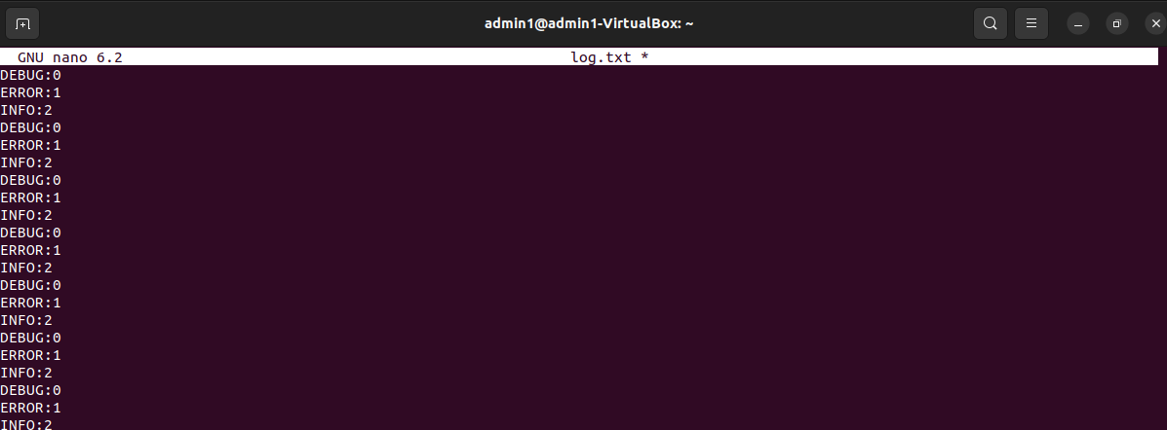
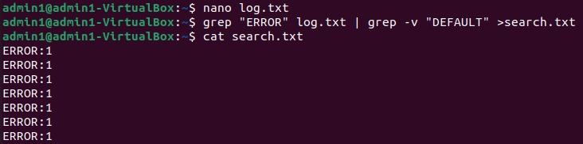

4) Write a code to identify the process with the highest memory usage and then terminate it.
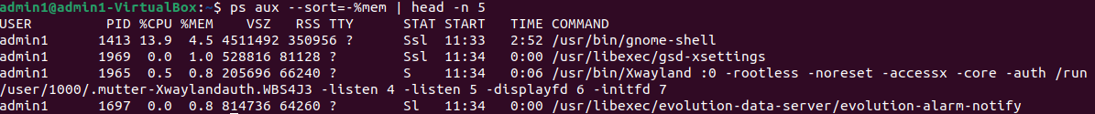
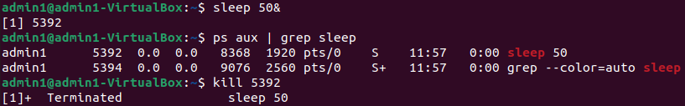

5) Use the networking tool command and print all the gateway available in asorted manner
